Hands On-1:Create a Spring Web Project using Maven
Spring Boot is a framework that simplifies the development of Java applications by providing pre-configured settings and embedded servers. Maven is a build automation tool that manages project dependencies and simplifies project compilation, testing, and packaging.
Code
SpringLearnApplication.java
package com.cognizant.spring_learn;
import org.springframework.boot.SpringApplication;
import org.springframework.boot.autoconfigure.SpringBootApplication;
@SpringBootApplication
public class SpringLearnApplication {
public static void main(String[] args) {
System.out.println("SpringLearnApplication main() method started.");
SpringApplication.run(SpringLearnApplication.class, args);
}
}
Output
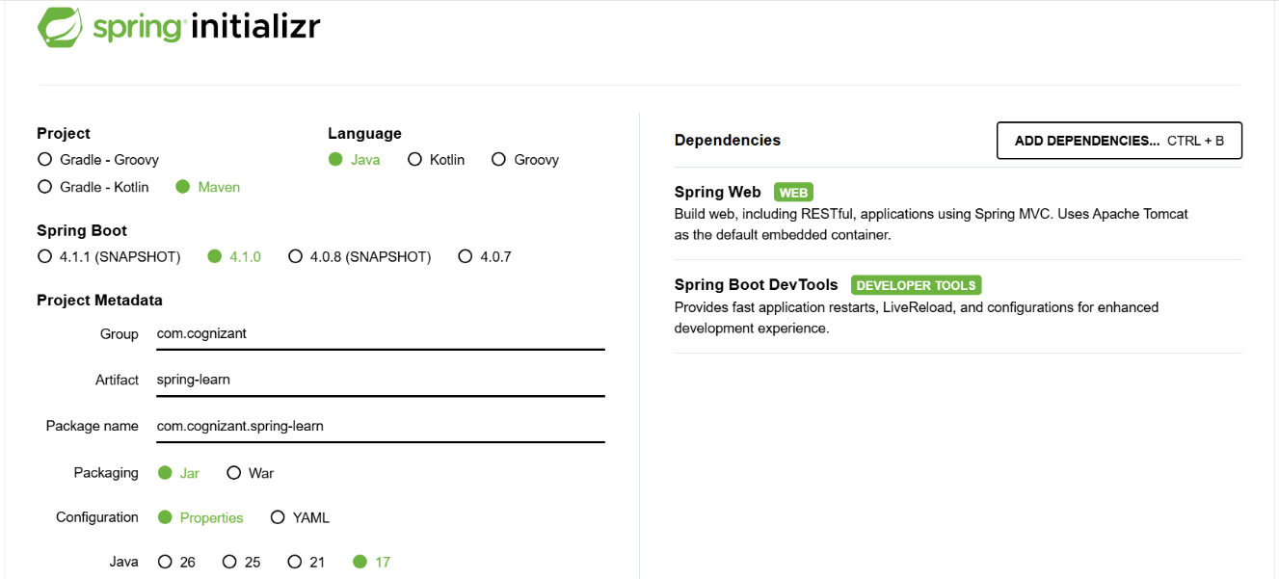
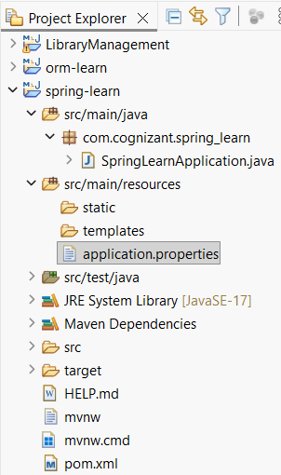
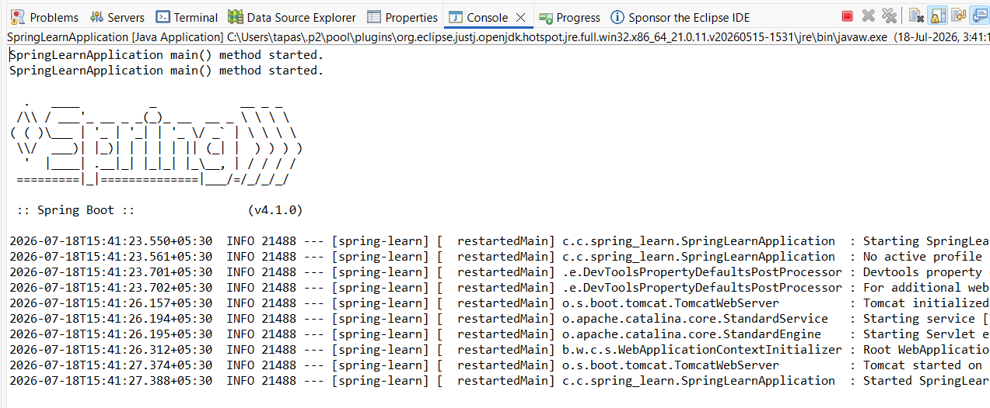

Hands-on 4 : Spring Core – Load Country from Spring Configuration XML
Spring Core provides the Inversion of Control (IoC) container, which manages the creation and configuration of objects called beans. Using an XML configuration file, bean properties can be defined and later loaded into the application through ApplicationContext.

Code
1. Country.java
package com.cognizant.spring_learn;
public class Country {
private String code;
private String name;
public Country() {
System.out.println("Inside Country Constructor.");
}
public String getCode() {
System.out.println("Inside getCode()");
return code;
}
public void setCode(String code) {
System.out.println("Inside setCode()");
this.code = code;
}
public String getName() {
System.out.println("Inside getName()");
return name;
}
public void setName(String name) {
System.out.println("Inside setName()");
this.name = name;
}
@Override
public String toString() {
return "Country [code=" + code + ", name=" + name + "]";
}
}

2. country.xml
<?xml version="1.0" encoding="UTF-8"?>
<beans xmlns="http://www.springframework.org/schema/beans"
xmlns:xsi="http://www.w3.org/2001/XMLSchema-instance"
xsi:schemaLocation="
http://www.springframework.org/schema/beans
https://www.springframework.org/schema/beans/spring-beans.xsd">
<bean id="country" class="com.cognizant.spring_learn.Country">
<property name="code" value="IN"/>
<property name="name" value="India"/>
</bean>
</beans>

3. SpringLearnApplication.java
package com.cognizant.spring_learn;
import org.springframework.boot.SpringApplication;
import org.springframework.boot.autoconfigure.SpringBootApplication;
import org.springframework.context.ApplicationContext;
import org.springframework.context.support.ClassPathXmlApplicationContext;
@SpringBootApplication
public class SpringLearnApplication {
public static void main(String[] args) {
SpringApplication.run(SpringLearnApplication.class, args);
displayCountry();
}
public static void displayCountry() {
ApplicationContext context =
new ClassPathXmlApplicationContext("country.xml");
Country country = context.getBean("country", Country.class);
System.out.println("Country : " + country);
((ClassPathXmlApplicationContext) context).close();
}
}

Output
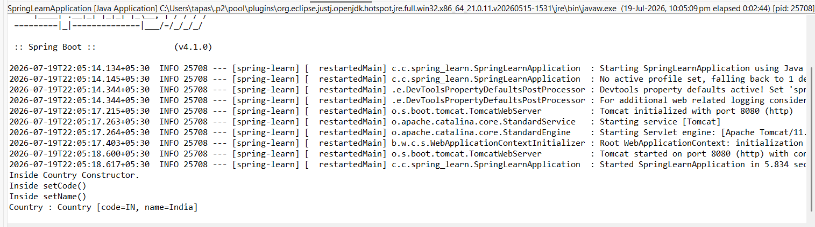

Experiment 1: Hello World RESTful Web Service
REST (Representational State Transfer) is an architectural style used to build web services over HTTP. In Spring Boot, the @RestController annotation is used to create REST APIs, while @GetMapping maps HTTP GET requests to a specific method. When the client sends a request, the server processes it and returns the required response.

Code
HelloController.java
package com.cognizant.spring_learn.controller;
import org.slf4j.Logger;
import org.slf4j.LoggerFactory;
import org.springframework.web.bind.annotation.GetMapping;
import org.springframework.web.bind.annotation.RestController;
@RestController
public class HelloController {
private static final Logger LOGGER =
LoggerFactory.getLogger(HelloController.class);
@GetMapping("/hello")
public String sayHello() {
LOGGER.info("START");
String message = "Hello World!!";
LOGGER.info("END");
return message;
}
}
Output
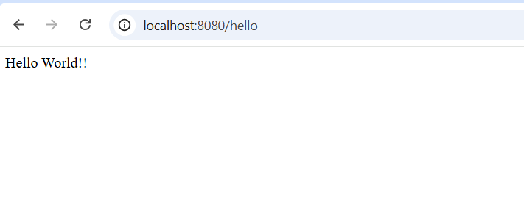
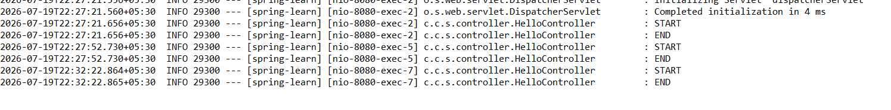
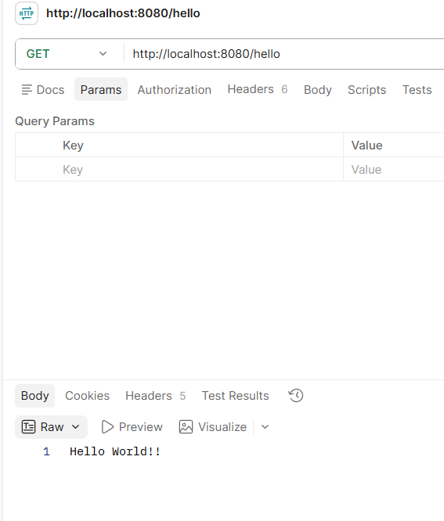

Experiment 2: REST - Country Web Service
A RESTful Web Service allows applications to exchange data over HTTP in a simple and efficient way. In Spring Boot, the @RestController annotation is used to expose REST APIs, and the returned Java object is automatically converted into JSON format using Spring's built-in Jackson library.

Code
Country.java
package com.cognizant.spring_learn;
public class Country {
private String code;
private String name;
public Country() {
System.out.println("Inside Country Constructor.");
}
public String getCode() {
System.out.println("Inside getCode()");
return code;
}
public void setCode(String code) {
System.out.println("Inside setCode()");
this.code = code;
}
public String getName() {
System.out.println("Inside getName()");
return name;
}
public void setName(String name) {
System.out.println("Inside setName()");
this.name = name;
}
@Override
public String toString() {
return "Country [code=" + code + ", name=" + name + "]";
}
}

country.xml
<?xml version="1.0" encoding="UTF-8"?>
<beans xmlns="http://www.springframework.org/schema/beans"
xmlns:xsi="http://www.w3.org/2001/XMLSchema-instance"
xsi:schemaLocation="
http://www.springframework.org/schema/beans
https://www.springframework.org/schema/beans/spring-beans.xsd">
<bean id="country" class="com.cognizant.spring_learn.Country">
<property name="code" value="IN"/>
<property name="name" value="India"/>
</bean>
</beans>

CountryController.java
package com.cognizant.spring_learn.controller;
import org.springframework.context.ApplicationContext;
import org.springframework.context.support.ClassPathXmlApplicationContext;
import org.springframework.web.bind.annotation.RequestMapping;
import org.springframework.web.bind.annotation.RestController;
import com.cognizant.spring_learn.Country;
@RestController
public class CountryController {
@RequestMapping("/country")
public Country getCountryIndia() {
ApplicationContext context =
new ClassPathXmlApplicationContext("country.xml");
Country country = (Country) context.getBean("country");
return country;
}
}

Output
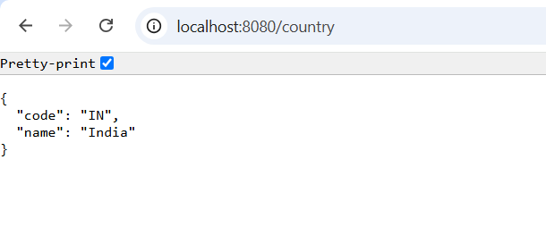
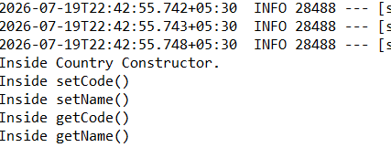

Experiment 3: REST - Get Country Based on Country Code
The @PathVariable annotation is used to capture values directly from the URL and pass them to a controller method. The controller invokes a service class to search for the required country from a list loaded from an XML configuration file. If the country code matches, the corresponding country object is returned as a JSON response.

Code
CountryService.java
package com.cognizant.spring_learn.service;
import java.util.List;
import org.springframework.context.ApplicationContext;
import org.springframework.context.support.ClassPathXmlApplicationContext;
import org.springframework.stereotype.Service;
import com.cognizant.spring_learn.Country;
@Service
public class CountryService {
@SuppressWarnings("unchecked")
public Country getCountry(String code) {
ApplicationContext context =
new ClassPathXmlApplicationContext("country.xml");
List<Country> countryList =
(List<Country>) context.getBean("countryList");
for (Country country : countryList) {
if (country.getCode().equalsIgnoreCase(code)) {
return country;
}
}
return null;
}
}

CountryController.java
package com.cognizant.spring_learn.controller;
import org.springframework.beans.factory.annotation.Autowired;
import org.springframework.web.bind.annotation.GetMapping;
import org.springframework.web.bind.annotation.PathVariable;
import org.springframework.web.bind.annotation.RestController;
import com.cognizant.spring_learn.Country;
import com.cognizant.spring_learn.service.CountryService;
@RestController
public class CountryController {
@Autowired
private CountryService countryService;
@GetMapping("/countries/{code}")
public Country getCountry(@PathVariable String code) {
return countryService.getCountry(code);
}
}

country.xml
<bean id="countryList" class="java.util.ArrayList">
<constructor-arg>
<list>
<bean class="com.cognizant.spring_learn.Country">
<property name="code" value="IN"/>
<property name="name" value="India"/>
</bean>
<bean class="com.cognizant.spring_learn.Country">
<property name="code" value="US"/>
<property name="name" value="United States"/>
</bean>
<bean class="com.cognizant.spring_learn.Country">
<property name="code" value="JP"/>
<property name="name" value="Japan"/>
</bean>
<bean class="com.cognizant.spring_learn.Country">
<property name="code" value="DE"/>
<property name="name" value="Germany"/>
</bean>
</list>
</constructor-arg>
</bean>

Output
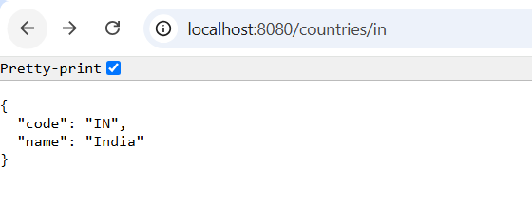
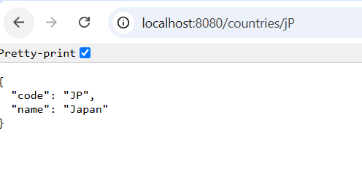

Create Authentication Service that Returns JWT
Authentication is the process of verifying a user's identity before allowing access to protected resources. In Spring Boot, a REST controller can expose an authentication endpoint using the @RestController and @GetMapping annotations. In this exercise, the service returns a sample response indicating that a JWT token has been generated.

Code
AuthenticationController.java
package com.cognizant.spring_learn.controller;
import org.springframework.web.bind.annotation.GetMapping;
import org.springframework.web.bind.annotation.RestController;
@RestController
public class AuthenticationController {
@GetMapping("/authenticate")
public String authenticate() {
return "JWT Token Generated";
}
}

Output
